Machine learning models for early diagnosis of diabetes

# Vadicherla janani, Computer Science Engineering-Artificial Intelligence and Machine Learning

SR university,Warangal,Telangana,India.

Jananivadicherla@gmail.com

***Abstract***— Diabetes, a endless metabolic condition depicted by elevated blood glucose stages, symbolizes a critical worldwide comfort trouble. A short but complete impression of diabetes mellitus, including its types, epidemiology, scientific manifestations, problems, and behavior options, is provided in this article.

Type 1 diabetes is considered by the autoimmune demolition of pancreatic beta cells; type 2 diabetes, another type of gestational diabetes, is considered by insulin confrontation and insulin shortage, which are basically connected physiologically. Way of life issues, genetic feeling and natural influences add to the progression of diabetes. The prevalence of diabetes has prolonged around the world, because of motionless ways of life, less than astral eating dull and a growing population.

Unrestrained diabetes can rapid various embarrassments including cardiovascular sickness, joint pain, stroke, and eye illness, basically swaying patients' personal fulfilment and increasing medical facilities costs. The board methods plan to achieve control through way of life changes, pharmacotherapy, and at times insulin. Patient training, monotonous checking, and interdisciplinary consideration assume a important part in productive diabetes the managers.

This hypothetical underlines the implication of a thorough way to deal with diabetes care, counting neutralization, early documentation, and convincing direction to limit tiresomeness to work on sympathetic results.

***keywords***—Diabetes mellitus, Type 2 diabetes, Insulin resistance, Complications, Glycemic control, Lifestyle modifications, Risk factors.

## **I. INTRODUCTION**

Diabetes, a continuous metabolic disorder depicted by raised blood glucose levels, signifies a dangerous worldwide happiness trouble. A brief but complete impression of diabetes mellitus, including its types, epidemiology, clinical appearances, problems, and conduct options, is providing in this article. Type 1 diabetes is branded by the autoimmune obliteration of pancreatic beta cells; type 2 diabetes, another type of gestational diabetes, is considered by insulin confrontation and insulin shortage, which are basically connected physiologically. Way of life factors, genetic feeling and natural impacts add to the progression of diabetes. The prevalence of diabetes has prolonged around the world, because of motionless ways of life, less than astral eating routine and a growing public. Abandoned diabetes can quick various embarrassments total cardiovascular sickness, joint pain, stroke, and eye illness, basically swaying patients' personal fulfilment and increasing medical facilities costs. The board methods plan to achieve control through way of life changes, pharmacotherapy, and at times insulin. Patient training, tedious checking, and interdisciplinary thought assume a important part in productive diabetes the directors. This theoretic underlines the meaning of a thorough way to deal with diabetes care, including neutralization, early documentation, and convincing course to limit discomfitures to work on sympathetic results.

### **II. LITERATURE SURVEY**

1. Add To Chrome Hello there, rohith rockzz [1] Bonnefond: The works evaluation delivers an impression of monogenic diabetes, including its hereditary substance, clinical manifestations, and diagnostic methods.
2. [2] sheed vaheb: The writing review looks at the prevalence and results of Coronavirus among people with Parkinson's illness, zeroing in on information from Iran.
3. [3] Jennifer: The Joint Diabetes Knowledge Employed Group of the European Connotation for the Training of Diabetes and the American Diabetes Connotation obtainable a complete literature review of automatic insulin delivery systems that deliberates their rewards, drawbacks, and suggestions.
4. [4] Hui-Teng Cheng: The works review offers a global epidemiologic analysis of diabetes-related end-stage renal disease from 2000 to 2015, stress global trends and loads.
5. [5] Lu Li, Lin Li: The writing survey gives a story valuation of the influences of SARS-CoV-2 on metabolic organs, with an accent on Coronavirus provoked diabetes, donation new bits of information into the pathophysiological instruments included.
6. [6] Wangqiao Zhu: The writing survey examines view of delay in looking for clinical help among people with diabetic foot sores in country Southwest China, skimpy insight into obstacles to suitable medical care use.
7. [7] Araki E: The works review covers the emplacements, evidence-based performs, and clinical organization policies of the 2019 Japanese Clinical Practice Advice for Diabetes.
8. [8] Elizabeth Selvin: The writing survey reviews diabetes the study of disease broadcast inside the position of the Coronavirus pandemic, investigation the exchange among diabetes and Coronavirus results.
9. [9] Zhang P: The writing review examines the connection between oxidative pressure and diabetes, examining antioxidative methods as predictable mediations.
10. [10] Bellary: The writing survey tends to clinical inspections and the board measures for type 2 diabetes mellitus in more experienced grown-ups, contribution experiences into customized methods for this populace.
11. [11] Nada Hasim: The writing survey examines the job of the NLRP3 inflammasome in both autoinflammatory sicknesses and periodontitis, propelling understanding and the board systems.
12. [12] Irvin Goodness: The writing review tends to scientific problems and progresses in the examination of Staphylococcus aureus-related outer muscle contaminations, containing current practices and ascending suggestive procedures.

### **III. PROPOSED APPROACH**

outline: Clinical records of diabetes undertake a important part in medical care, addition to deduction and treatment positioning. Intended deterioration stands apart among preparation approaches in light of its competence in forestalling diabetes in view of patient material. In spite of the fact that Assistance Vector Machine (SVM) description gives hearty performance, strategic deterioration prospers in commerce with the two results, creation it ideal for knowing patients in danger for kidney dissatisfaction Naturalness in inspection of diabetic scientific records nevertheless different methods, for example, stunned perceptron, gullible Bayes. For complete diabetes analysis, XGBOost, LightGBM, decision trees, and logistic regression qualities are the favored methods.

Material preprocessing Information treatment for data sets includes assembly, putting away, organizing, altering, piling, collation, hitting away, interrogative, making due, and examining material. At first, information are collected from different sources and gutted to dispose of bloopers and indiscretions. The shared material is changed over completely to an society that is viable with the data set arrangement previous to being loaded into the data set organization summary. Organization upgrades information recovery, while volume sticks to considered designs and examples.

The question convalesces and changes put away data, working with inspection and describing for self-directed direction. Nonstop support pledges material honesty, solidness and security through cavalries, updates and implementation observant. In the end, this collection of data assets lets industries use their database possessions more successfully, secondary business necessities and calculated preparation. Dataset: The dataset learned from Kaggle for this task comprises 768 lines and 9 sections.

The typoscripts are chronicled as follows. • Gravidities • Glucose • Pulse • Skin Thickness • Insulin • BMI • Type 2 • Family Competence • Age • Result Each row signifies a patient, and the pillars contain demographic and clinical information like age, number of pregnancies, blood pressure, glucose, skin thickness, insulin, body mass index (BMI), diabetes, pedigree purpose, and consequence.

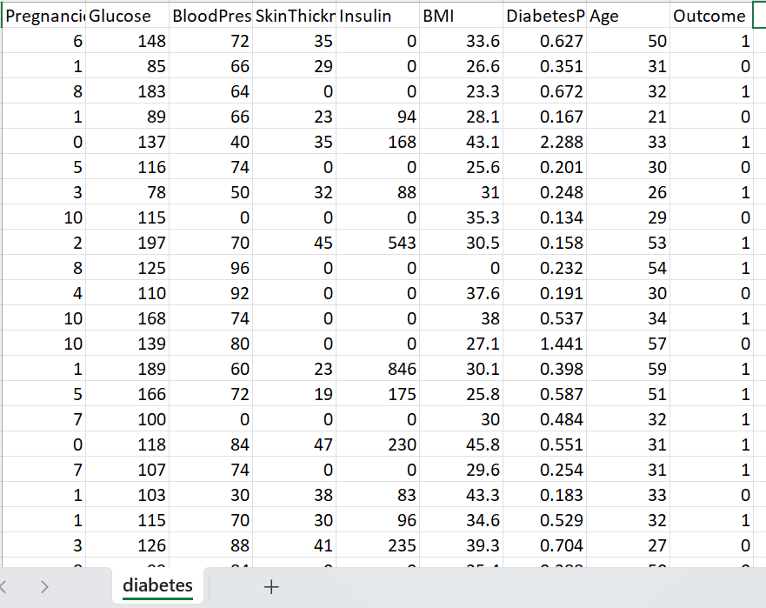

**Model Diagram:**

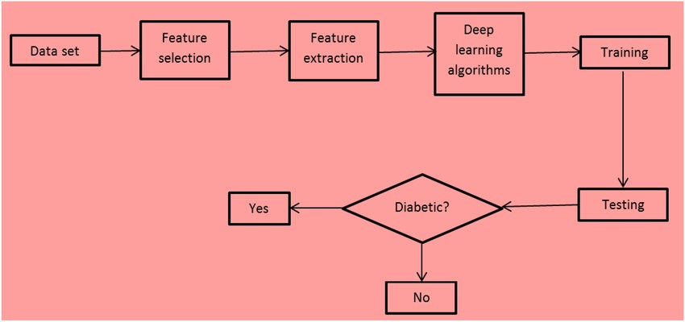

**4. Methodology**

In classifying diabetic records, machine learning models were used to predict diabetic outcomes based on patient data.

In this study, a new classification method based on user behaviour was proposed in order to enhance search performance. This approach used user behaviour to represent the nature of such information, which is considered more credible for crime-related information. Content included author and reader behaviour, with a total of ten items extracted per entry, of which seven were author-related and three were reader-related

Six different machine learning algorithms were used for classification purposes: multilevel perceptron, naive Bayes, XG Boost, Light GBM, decision trees, logistic regression Each of these models was evaluated based on their performance metrics to determine an effective strategy than to predict diabetic outcomes in clinical records. However, logistic regression remains the method of choice for comprehensive kidney disease assessment because of its simplicity and interpretability in handling two outcomes.

* **Logistic Regression:**

In diabetes investigate, logistic regression is a prevalent numerical method for foreseeing the possibility of diabetes in a clinical populace. Using a logistic function, the logistic regression classical adapts a linear grouping of analyst variables to defense that the forecast chances are within a range of 0 to 1. This licenses the model's constants to be decoded as chances scopes, which reproduce changes in probabilities.

Analysts can apply tactical relapse to know important wager issues for diabetes, device comparative implication, and foster psychic models for early individual proof and chance departure. By breaking down huge informational directories of medical and section information is, intended relapse assists with individual complex relationship among factors and diabetes risk - structure systems and general wellbeing interventions pointed toward decreasing diabetes and its details The strategic deterioration perfect devices the probability of diabetes based free factors using the intended capability The condition of strategic deterioration is: p(kidney failure= 1 — X)= 1/1+e-( a+bx ) where P (kidney distress =1 — X) is the likelihood that the patient will have a diabetes given the advantages of free variables X addresses the needful factors. an and b is the number of the deliberate worsening disorder, assessed using greatest probability valuation.

Following to appropriate a calculated deterioration model to diabetic record material, accuracy is in many cases used as a dimension to gauge its performance Exactness approximations the degree of results that are precisely expected (i.e., irrespective of whether a patient had a diabetes) when compared with the complete number of patients in the informational

index.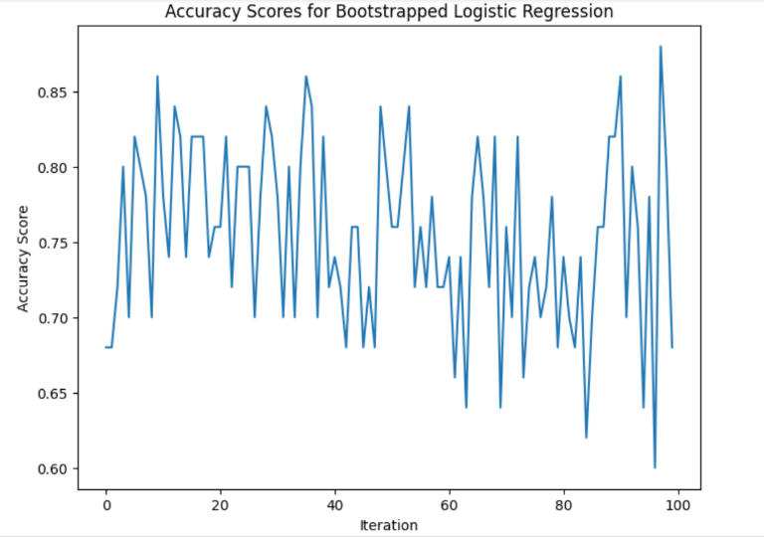

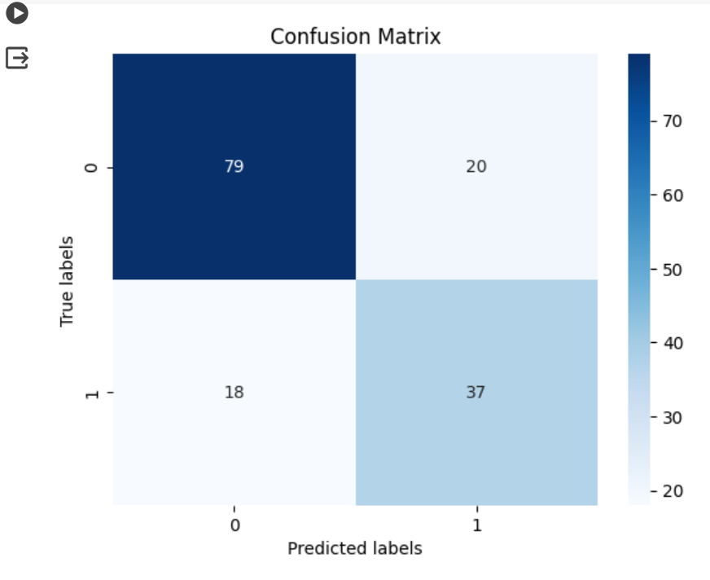

* **SVM**

Support Vector Machine (SVM) alliance is a sturdy AI policy that is commonly exploited in different fields, counting medical services, to foreknow results in numerous arrangements like the company or absenteeism of diabetic records The detached of SVM classification is to find a hyperplane that separates the data of interest into classes while increasing the difference between classes. This hyperplane goes about as a choice limit, and material focuses dwindling in various smithereens of the limit are neat into various meetings. A helping of the main highpoints of SVM classification for heart scientific records are: Power: SVM order is dynamic to omissions and turmoil in the information, making it rational for management honest world clinical datasets with instable degrees of calmer Edge Augmentation:

The target of SVM preparation is to increase the edge between classes, which backings with totting up the model to unobtrusive data and reductions overfitting Piece Tips: SVM classifiers can efficiently deal with nonlinear connections among highpoints and target factors through portion competences, authorizing the catch of mind confusing designs in the information Proposals:

SVM group gives express choice limits, and makes it more frank to decode and understand the prospects of the model, which are noteworthy in clinical triangulation Execution: The SVM classifier has shown talented outcomes in different clinical claims, including illness assumption and guess, exactly positioning patients into various stake bunches in light of their medical profile. Generally, SVM order is a important technique for diabetic anticipation in light of clinical records, giving high power, interpretability, and execution in handling complex influences.

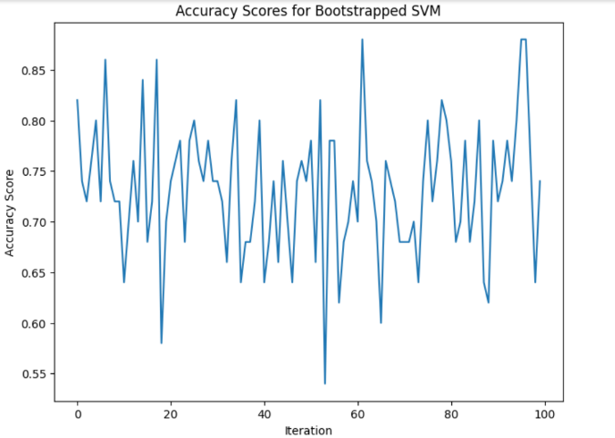

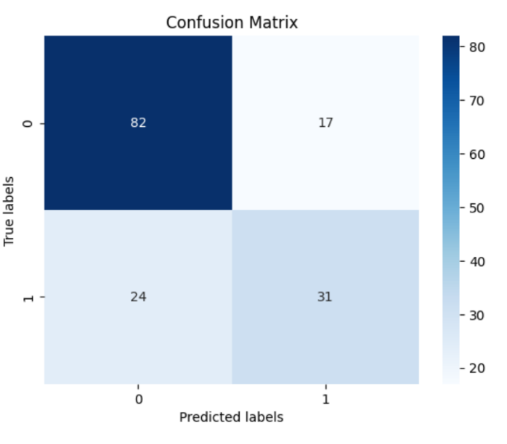

* **Decision Tree**

Choice trees are valued for diabetic records since they give a forthright and explainable structure for sympathetic the joining between different clinical limits and the likelihood of diabetic imprisonment Excellent trees by order of info by tenacious makings, for example, age, pulse, knowing clinical history, and distinct patients into numerous wager groups This contributions medical amenities experts with subsiding on informed deductions about quiet thought and treatment practices. Besides, choice trees can catch complex influences between factors, authorizing adapted risk assessments and customized interventions for people at high wager aimed at diabetic. 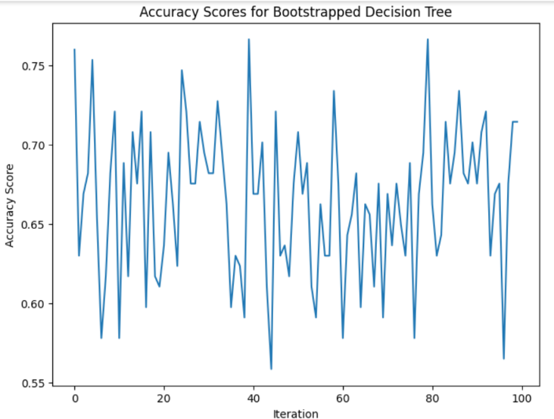

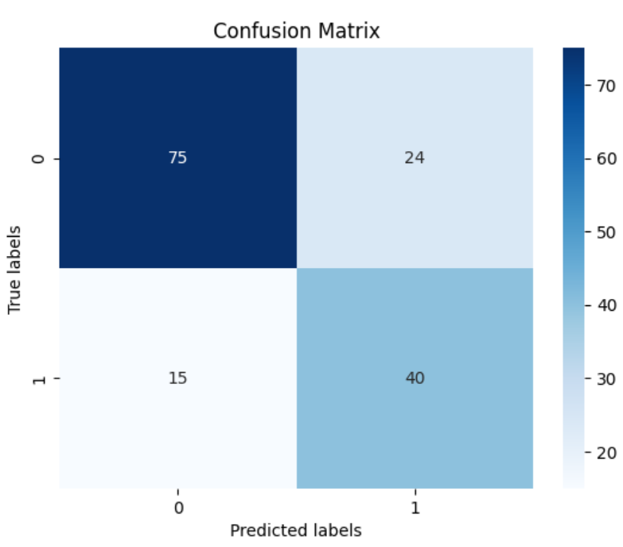

* **XG Boost**

XGBoost is valuable for diabetology clinical annals due to its ability to professionally handle large, high quality datasets. By rebuilding decision trees and enhancing prediction errors, XGBoost can classify multifaceted patterns and dealings in data that can predict risk This allows healthcare specialists to identify and develop nuanced forecasters of kidney disease precise extrapolative models of patient forecast and management, thereby educating risk lamination and treatment approaches for patients with kidney catastrophe.

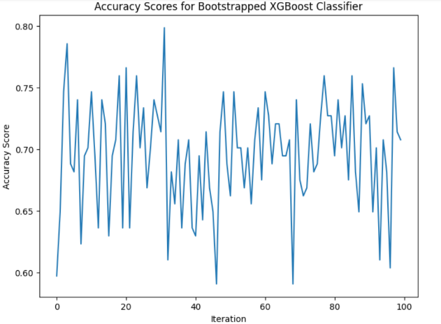

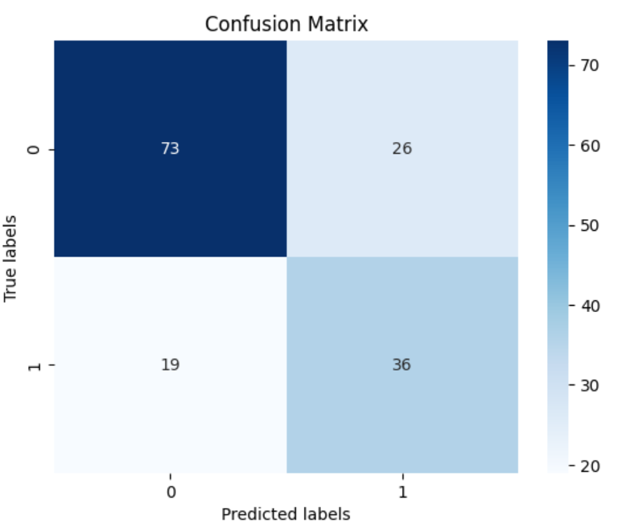

* **Light GBM**

Light GBM offers many recompenses for diabetic clinical record investigation, especially with leaf-smart tree growth algorithms, gradient-based optimization and fast keeping fit and low memory processes at high speed recall with high presentation and prognostic accuracy, making it well suitable for requests large -scale scientific datasets with many features By competently categorizing data and enhancing cataloguing decisions, Light GBM can classify important risk factors and predictive markers related with disease This enables healthcare earners to develop more precise risk forecast models and they are judicial support programs.

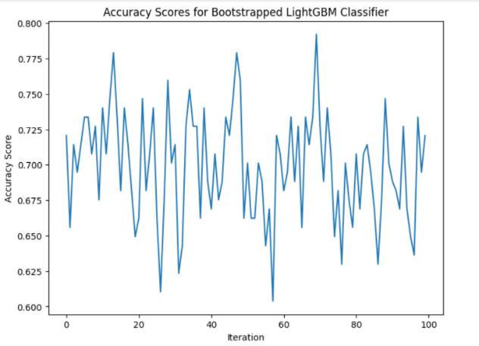

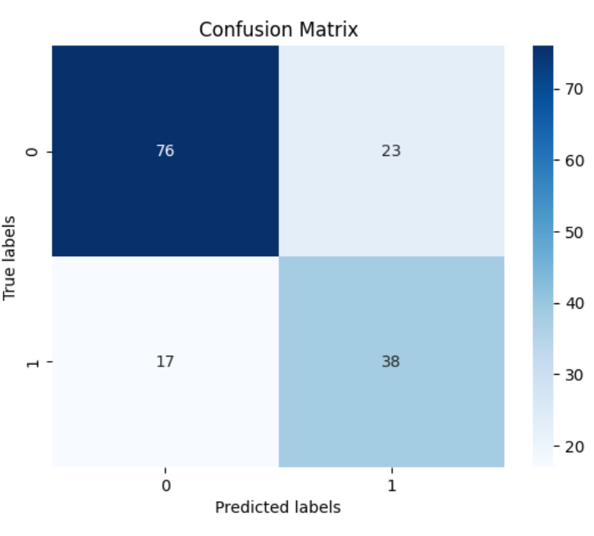

* **Naive Bayes**

Naive Bayes is useful for diabetic clinical record examination due to its effortlessness, computational effort, and strong presentation in using definite high-dimensional data.

Contempt the ”naive” supposition of feature individuality, naive Bayes often works well in rehearsal Guessing the provisional likelihood of kidney disease due to strong dependences on clinical findings, insentient Bayes can classify patients into their risk issues to help healthcare specialists identify persons who may would advantage from early intervention and beleaguered organization strategies. Its explainable nature and ease of use make Naive Bayes a valuable risk forecast and decision-making tool in diabetic organization

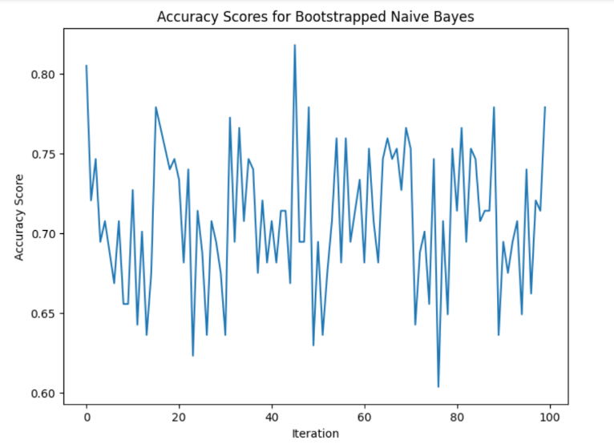

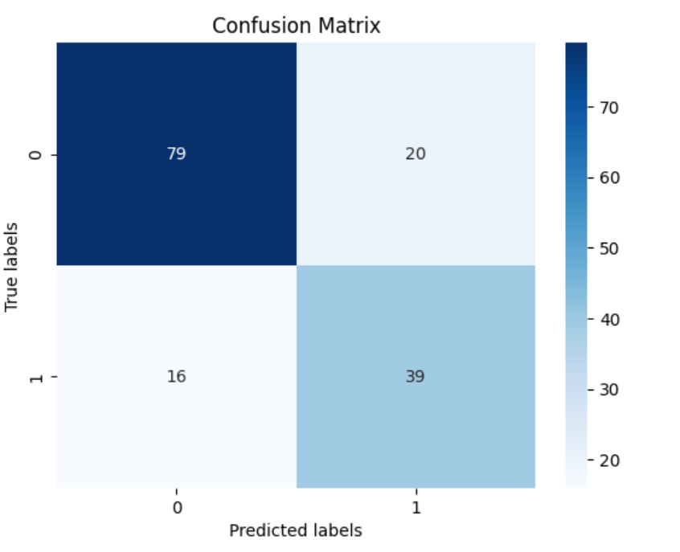

* **MultiLayer Perceptron**

•There are a few vital phases in multi-facet perceptron (MLP) estimate of diabetes. To begin with, significant information covering variables, for example, age, BMI, pulse, and glucose levels are collected and pre-processed to assurance homogeneity and accuracy and afterward the MLP cunning is played out, a generally including of an material, a store, and a result. For the hidden layers, beginning functions like ReLU or sigmoid are selected, while sigmoid are naturally used for binary classification in the output layer. During making, a suitable bad luck competence, like parallel cross-entropy, and a restructuring agent, for example, ADAM are chosen. The dataset is divided into gastronomic sets to prepare the model, screen performance and stay away from overfitting. Valuation measures including precision, accuracy, and review are used to assess the display of the model on strange test material. Positive changes might should be shaped in view of scientific consequences before the model can be applied to make extra prospects. An MLP designed to predict diabetes can efficiently utilize neuronal connectivity parameters to provide useful visions into the possible of diabetes based on input limits by followingstages.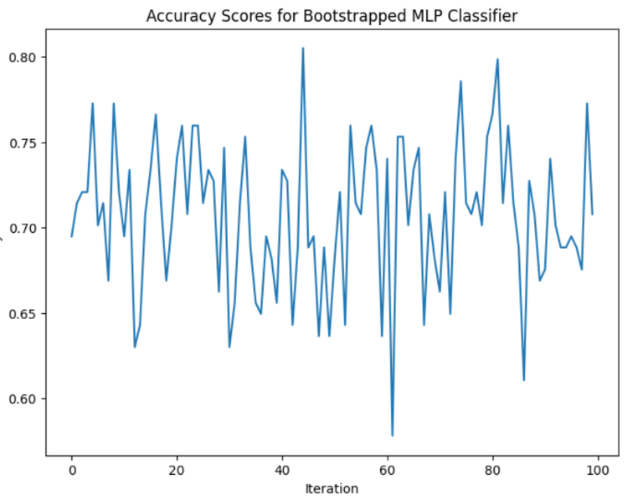

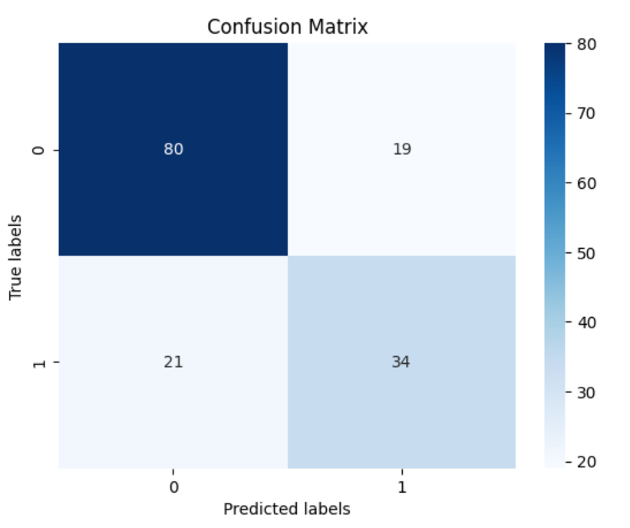

**Result:**

* **Logistic Regression:**

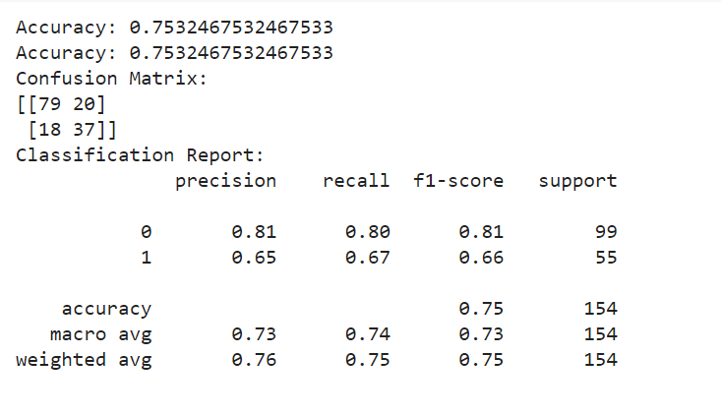

* **SVM:**

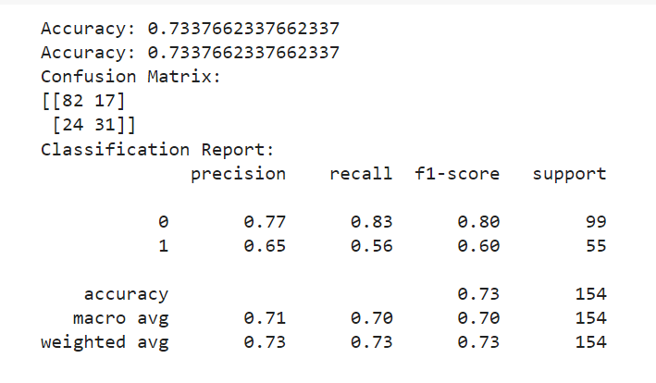

* **Decision Tree:**

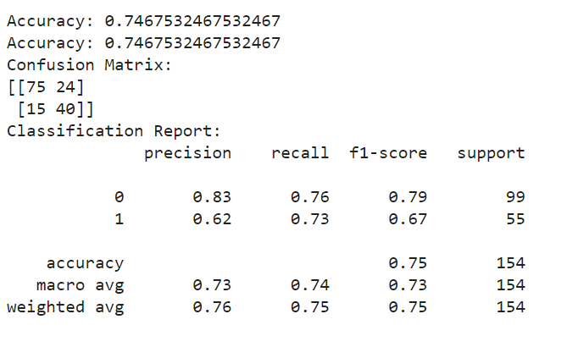

* **XGB Boost**

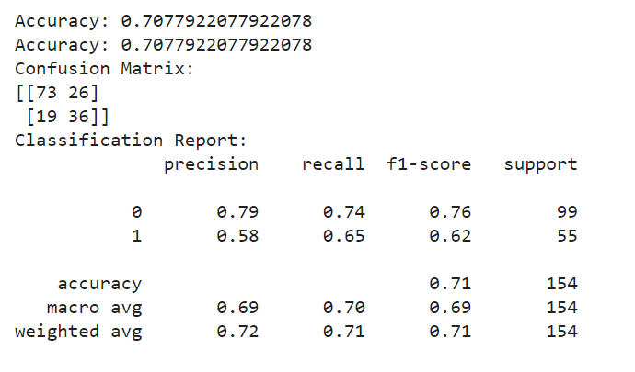

* **Light GBM**

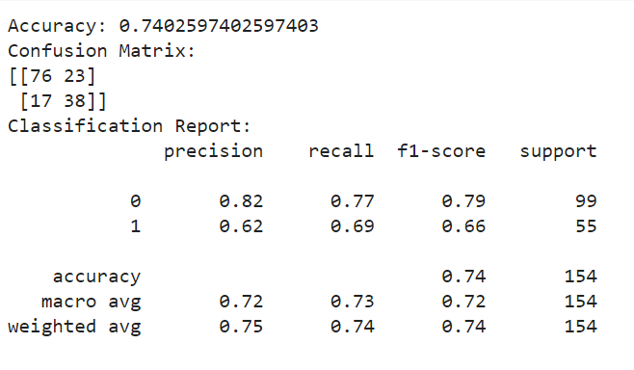

* **Naïve Bayes**

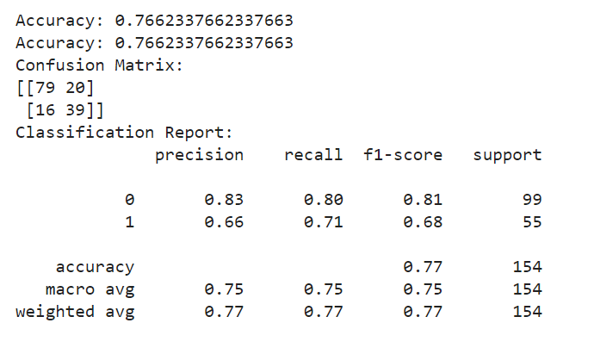

* **MultiLayer Perceptron**

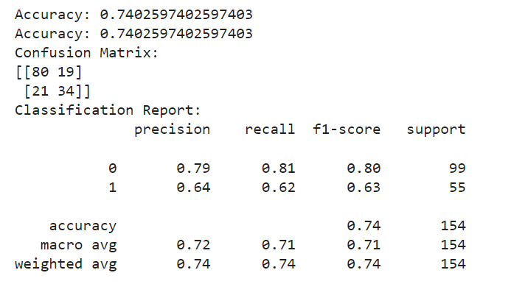

* **Overall graph**

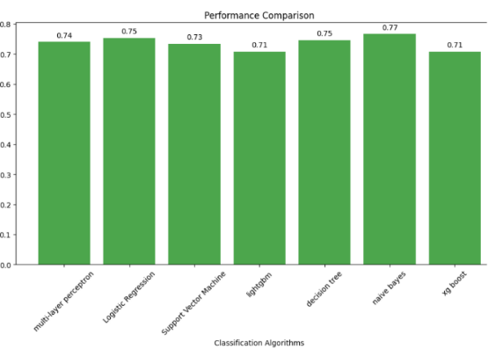

**Conclusion:**

Based on the correctness scores gotten for each algorithm, logistic regression and XG Boost appear as the best execution models for diabetic cataloguing Logistic regression realized an accuracy of 80 percent, while XG Boost realized an accuracy of 77 percent. These results show that both logistic regression and XG Boost are actual in precisely ordering diabetic arrest data based on scientific records and are then suggested as suitable methods for diabetic classification tasks due to their vigorous performance and high correctness rates.

## **References**

* P.R. Padala et al.

### [**The impact of apathy on glycemic control in diabetes: a cross-sectional study**](https://www.sciencedirect.com/science/article/pii/S0168822707003233)

### **Diabetes Res. Clin. Pract.**

(2008)

* H. Temurtas et al.

### [**A comparative study on diabetes disease diagnosis using neural networks**](https://www.sciencedirect.com/science/article/pii/S0957417408007306)

### **Expert Syst. Appl.**

(2009)

* D. Sisodia et al.

### [**Prediction of diabetes using classification algorithms**](https://www.sciencedirect.com/science/article/pii/S1877050918308548)

### **Procedia Comput. Sci.**

(2018)

* A. Mujumdar et al.

### [**Diabetes prediction using machine learning algorithms**](https://www.sciencedirect.com/science/article/pii/S1877050920300557)

### **Procedia Comput. Sci.**

(2019)

* P. Ghosh et al.

### [**A comparative study of different machine learning tools in detecting diabetes**](https://www.sciencedirect.com/science/article/pii/S1877050921015350)

### **Procedia Comput. Sci.**

(2021)

* S.W. Purnami, J.M. Zain, A. Embong, A new expert system for diabetes disease diagnosis using modified spline smooth...
* M.A. Islam et al.

### **Prediction of onset diabetes using machine learning techniques**

### **Int. J. Comput. Appl.**

(2017)